

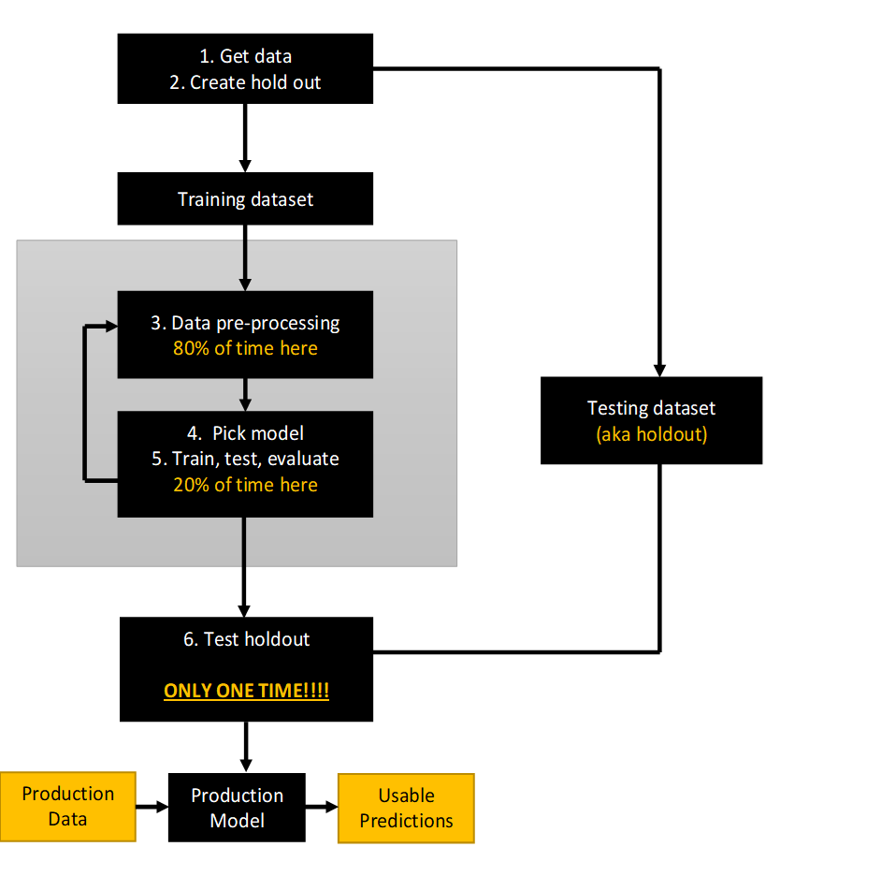

4. Pick model

5. Train, test, evaluate

20% of time here

Testing dataset

(aka holdout)

Usable Predictions

Production

Model

Production Data

6. Test holdout

**ONLY ONE TIME!!!!**

1. Get data

2. Create hold out

Training dataset

3. Data pre-processing

80% of time here